Build a Combination Chart

Combination charts are views that use multiple mark types in the same visualization. For example, you may show sum of profit as bars with a line across the bars showing sum of sales. You can also use combination charts to show multiple levels of detail in the same view. For example, you can have a line chart with individual lines showing average sales over time for each customer segment, then you can have another line that shows the combined average across all customer segments.

To create a combination chart, follow the steps below:

1. Open Tableau Desktop and connect to the **Sample - Superstore** data source.
2. Navigate to a new worksheet.
3. From the **Data** pane, under Dimensions, drag **Order Date** to the **Columns**shelf.
4. On the Columns shelf, right-click **YEAR(Order Date)** and select **Month**.

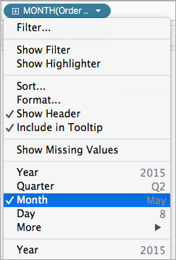

1. From the **Data** pane, under Measures, drag **Sales**to the **Rows**shelf.
2. From the **Data** pane, under Measures, drag **Profit**to the **Rows**shelf and place it to the right of SUM(Sales).
3. On the Rows shelf, right-click **SUM(Profit)** and select **Dual-Axis**.

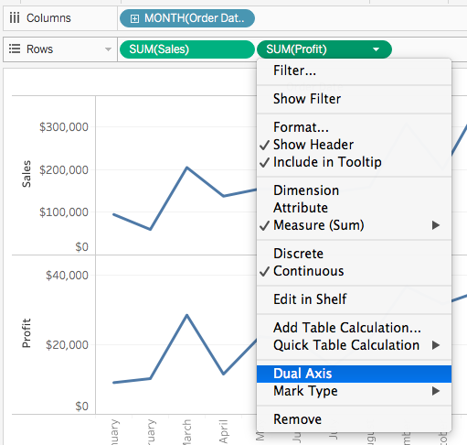

The view updates to look like the following. Measure Names is added to Color on the Marks card to differentiate the lines.

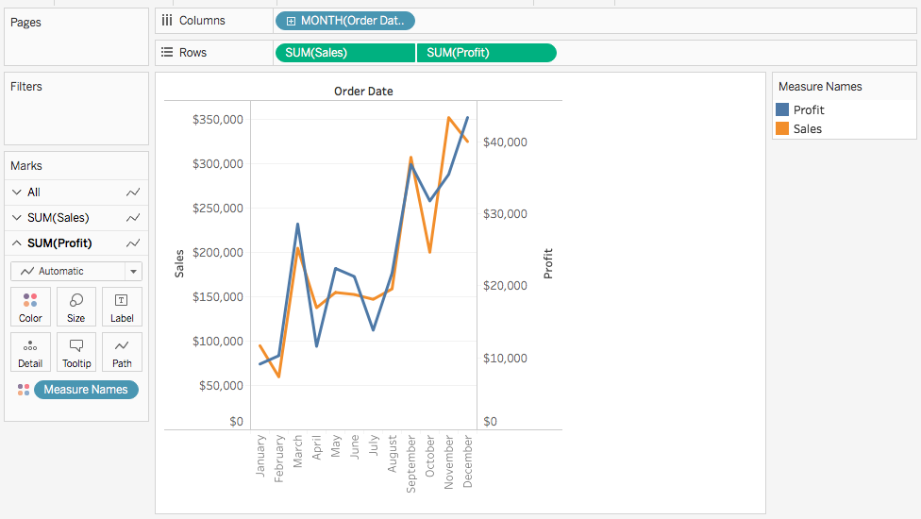

**Note**: Some marks can be hidden behind others. To move the marks forward or backward, right-click one of the axes in the visualization and select Move Marks to Back or Move Marks to Front.

1. On the SUM(Profit) Marks card, click the Mark Type drop-down and select **Bar**.

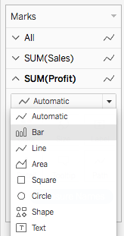

1. In the visualization, right-click the **Profit**axis and select **Synchronize Axis**.

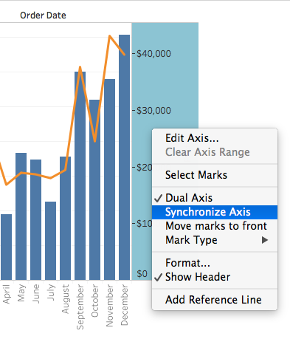

The visualization updates to look like the following.

